

**Aero Engine Technology – Assignment 3, Turbomachinery**

AE4238

FRANCESCO GRANATA 5394570 - VINCENZO NUGNES 5393957 – francisco dos santos 5040396

Index

**1.** **Introduction** 3

**2.** **Assumptions** 3

**3.** **Procedure** 3

**4.** **Results and observations** 4

**5.** **Conclusions** 6

# **Introduction**

The aim of this document is to develop the conceptual design of the high-pressure compressor for the Energy Efficient Engine by NASA. The task was pursued through multiple steps. Firstly, the initial parameters were set, as well as the number of stages of the axial compressor. Successively, the specific work and the isentropic efficiency of each stage were calculated in order to obtain from the Smith Chart. Thanks to these values, the design of the first stage was completed, obtaining the values of the radii and the velocity triangles. In conclusion the procedure was repeated for all the stages.

|  |  |  |  |
| --- | --- | --- | --- |
|  |  |  |  |
|  | Mass flow |  | Meridional speed |
|  | Corrected mass flow |  | Absolute Speed at the rotor inlet |
|  | Total pressure |  | Absolute Speed at the rotor outlet |
|  | Reference pressure |  | Inlet speed relative to the rotor reference frame |
|  | Total temperature |  | Outlet speed relative to the rotor reference frame |
|  | Reference temperature |  | Peripheral speed |
|  | Maximum pressure ratio per stage |  | Maximum peripheral speed |
|  | Compressor pressure ratio |  | Stage external radii |
|  | Degree of reaction |  | Stage internal radii |
|  | Flow coefficient |  | Angolar speed |
|  | Load coefficient |  | Polytropic efficiency |

# **Assumptions**

* Perfect gas: specific heats are constant.
* Adiabatic compressions and expansions in the stages.
* Mass conservation throughout the compressor.
* Non-isentropic thermodynamic transformations.
* Specific work of the compressor equally distributed among the stages.

# **Procedure**

The procedure which the calculations are based on is shortly explained in this paragraph. The results and plots are obtained with the MATLAB code attached at the end of this document, in which the reader can also find the input data considered.

* Real mass flow: ;
* Number of stages:

1. Fix the maximum pressure ratio for the first stage , this value was chosen to make sure the operation is stable, and stall is avoided;
2. Estimate maximum stage specific work: , the given value of polytropic efficiency was used in the calculation;
3. Total specific work: ;
4. Number of stages: rounded to the closest above integer;
5. Stage specific work: ;

* Single stage pressure ratio: ;
* Stage specific work: ;
* Isentropic efficiency: ;
* Fixing the values for degree of reaction and load coefficient and considering the isentropic efficiency calculated before, the flow coefficient is determined by the Smith Chart, and then tuned to obtain the best configuration and suitable speed at blade tips:

; (final values obtained after tuning).

* Velocity triangles: ;

;

;

;

* Meridional rotational speed: ;
* Velocities: ;

;

;

;

;

* Temperature at the stage outlet can be found from the total enthalpy relation;
* Density was instead calculated through the isentropic relation;
* Maximum rotational velocity at the blades tip was imposed in order to avoid sonic conditions: ;
* Then, the following system of three equations in the three unknowns was implemented:
* In conclusion a cycle was implemented to repeat the calculations for each stage.
* Total to total efficiency:
* Total to total efficiency:

# **Results and observations**

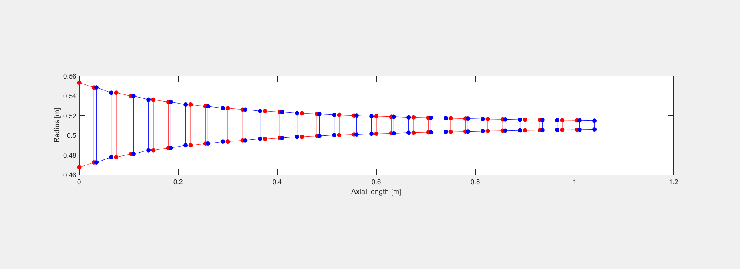

Fig. 4.1 Meridional Gas Path

Every stage is designed in such a way that the velocity at the stator exit is equal to the one at the rotor inlet, therefore the velocity trend is equally repeated at every stage. However, the pressure increases monotonically stage by stage, as shown in Fig 4.3, and that implies an increase in density. Therefore, being the design velocity constant, the density increasing and the mass flow rate constant for the continuity equation , we can deduct that the area has to decrease towards the exit section of the compressor. This conclusion explains the trend in Fig 4.1 and also imposes a geometrical limit on the number of stages that can be used in an axial compressor.

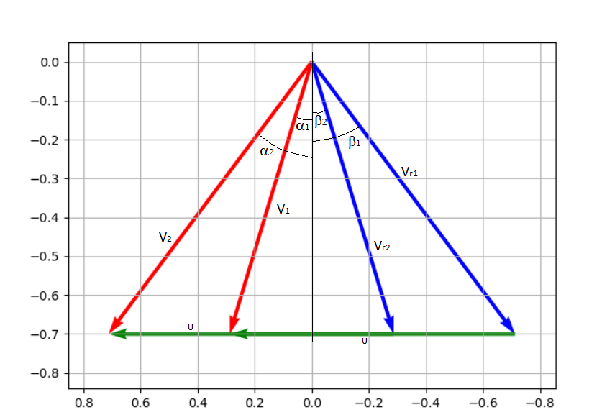

|  |  |
| --- | --- |
|  |  |
|  |  |
|  |  |
|  |  |
|  |  |
|  |  |
|  |  |
|  |  |
|  |  |
|  |  |
|  |  |

Tab 4.1

Fig 4.2 Velocity triangles

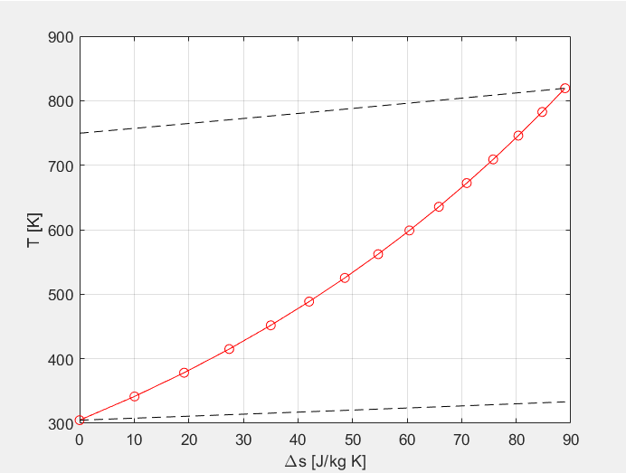

Fig 4.3 h-s diagram

It is possible to notice that the increment in entropy decreases stage by stage, while the increase in enthalpy is constant along the gas path. Moreover, it is noticeable that the work required to obtain the design pressure ratio is higher than the ideal isentropic case (which results obvious by looking at the isobars in black in Fig 4.3 that represent the isobars at the inlet and outlet of the compressor).

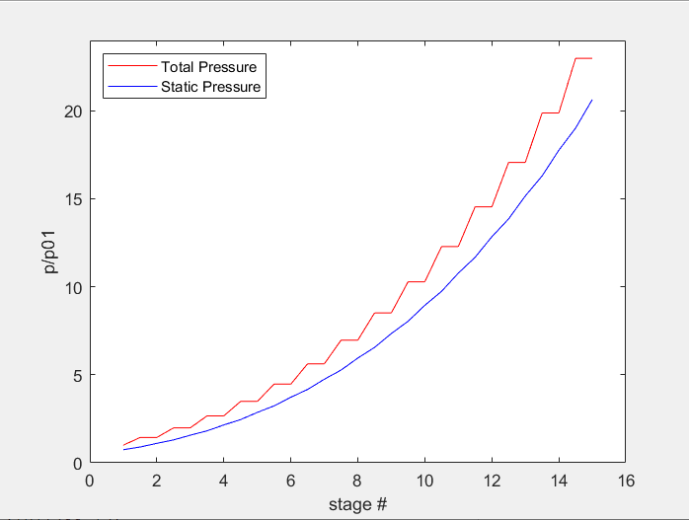 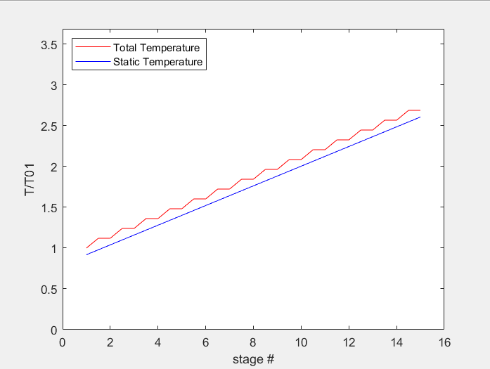

Fig 4.3 dimensionless static and total pressure Fig 4.4 dimensionless static and total temperature

Total pressure as well as total temperature stays constant in the stator and only increases in the rotor, while the static variables increase along the whole gas path. Moreover, as already noticed in the h-s diagram, both static and total temperature (taking into account the fact that the second only increases in the rotor) increase linearly.

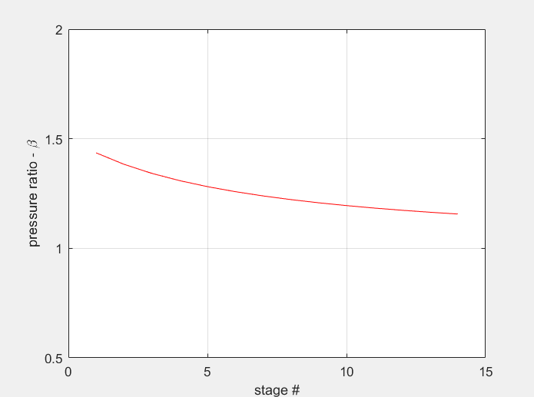

\Fig 4.6 Pressure ratio along the gas path

The pressure ratio decreases in the compressor as a consequence of the fact that the specific work for each stage was imposed to be constant.

# **Conclusions**

* Under the assumptions above mentioned, the design procedure led to a 14 stages compressor that allow the required pressure ratio (). Moreover, the designed compressor presents an axial length of 1.04 m and a maximum diameter of 1.11 m.
* The velocity triangles computed for the compressor show the characteristics of a compressor with a degree of reaction r* = 0.5, indeed and .